**CHAPTER 3**

**INFORMATION OF TEACHERS IN TU(MEIKTILA)**

**3.1. Block Diagram of Information of Teachers in TU (Meiktila)**

Information of Teachers in TU (Meiktila) includes one flowchart for admin of HR as shown in Figure 3.1.

Figure 3.1 Block Diagram For The Teachers

**3.2. Welcome Page**

Firstly, on this page, the user will see webpage view of home page as shown in Figure 3.2.

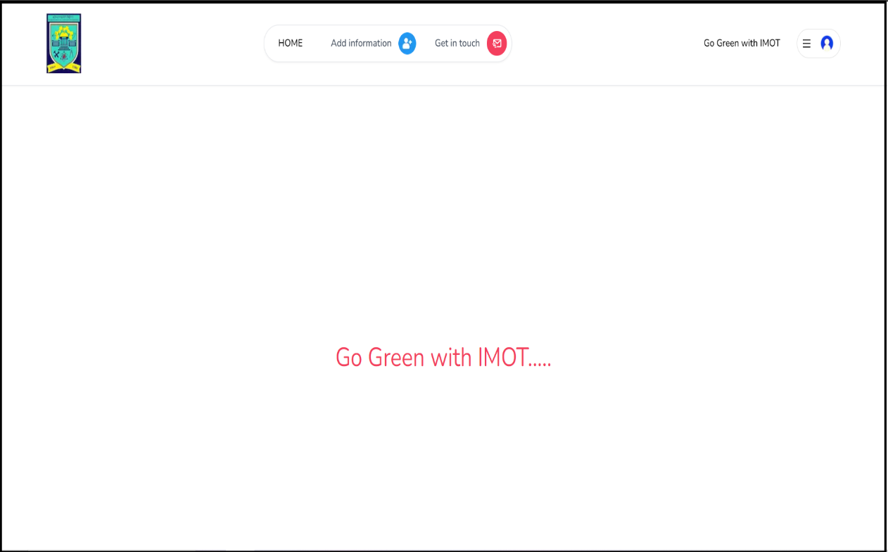Figure 3.2 Welcome Page

**3.3. Add Data Page**

If the teacher wants to add data, click on the add information button. Then it will show an information add page as shown in Figure 3.3.

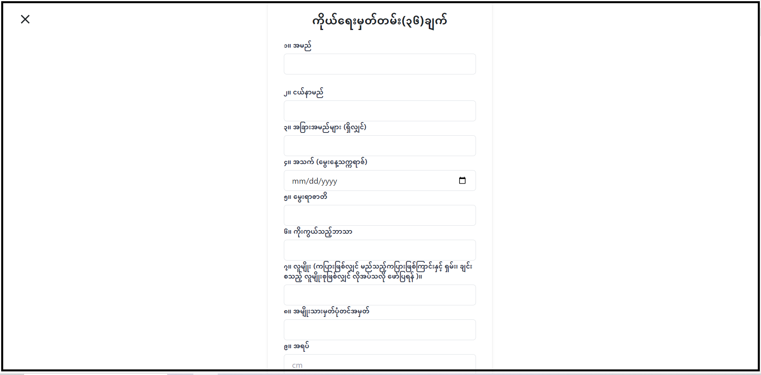Figure 3.3 Information Add Page

**3.4. Response Page**

After registration, a response page will appear as shown in Figure 3.4.

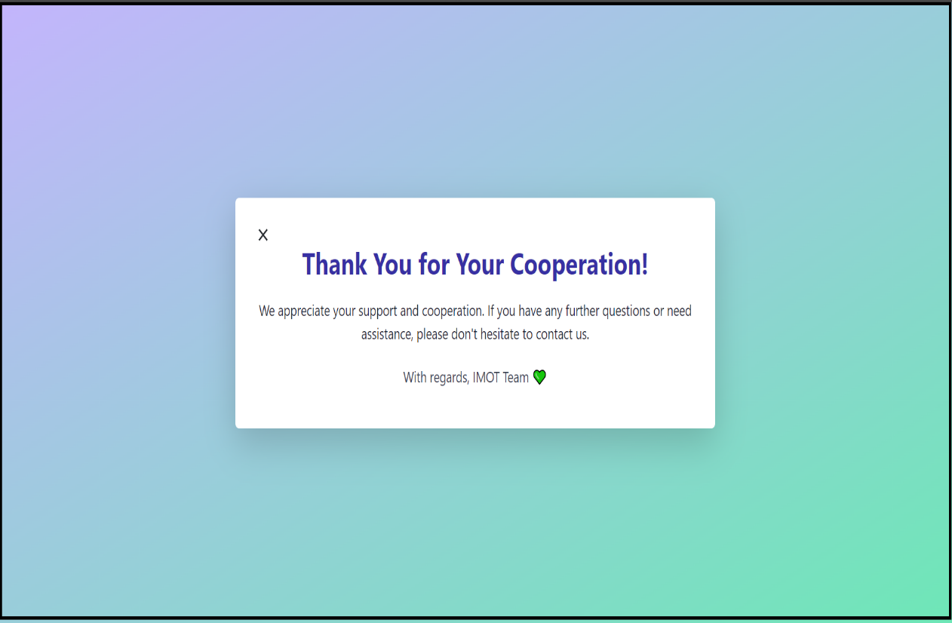Figure 3.4 Response Page

**3.5. Contact Page**

When clicked on Get in touch it will show a contact page as shown in Figure 3.5.

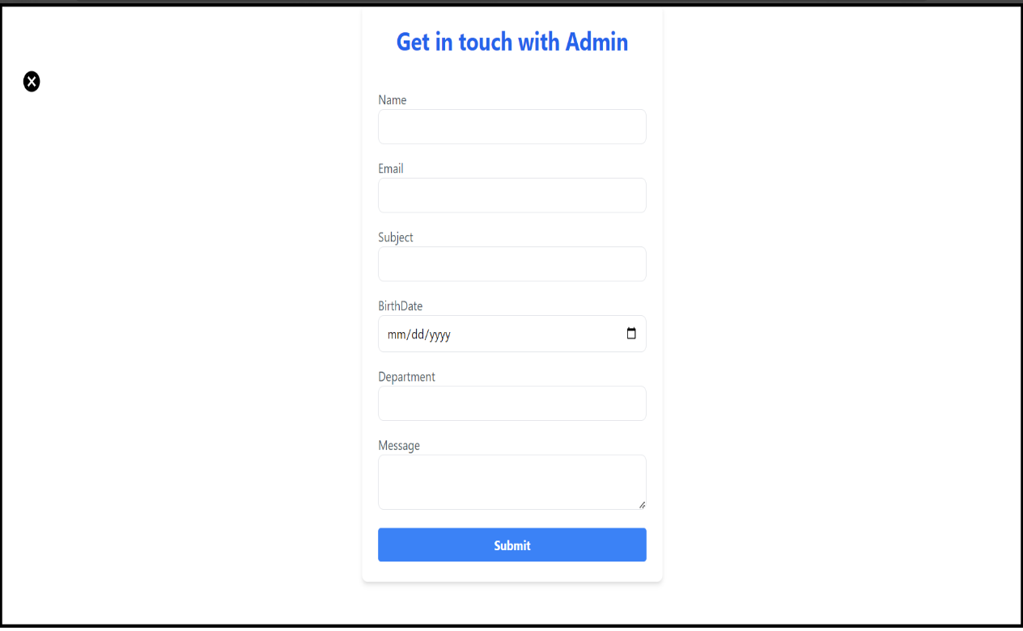Figure 3.5 Contact Page

**3.6. Admin Registration Page**

In this page, admin can register as shown in Figure 3.6.

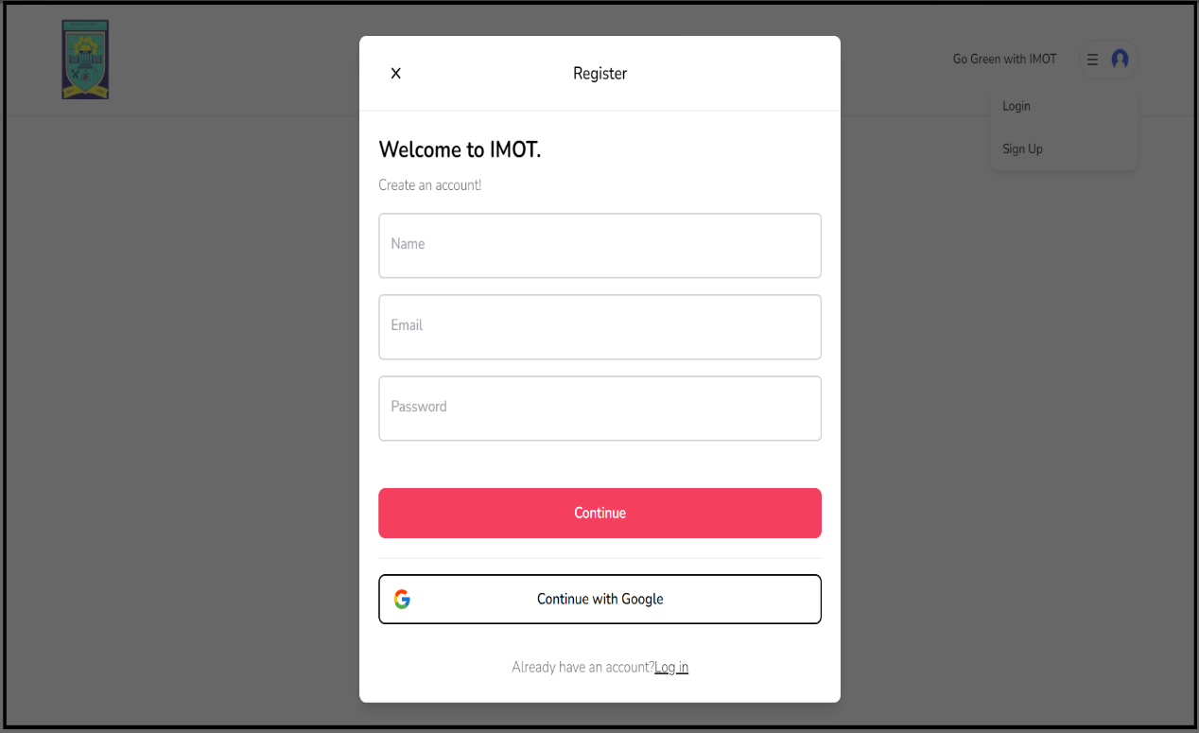Figure 3.6 Admin Registration Page

**3.7. Admin Login Page**

In this page, an Admin can login to that system to handle data as show in Figure 3.7.

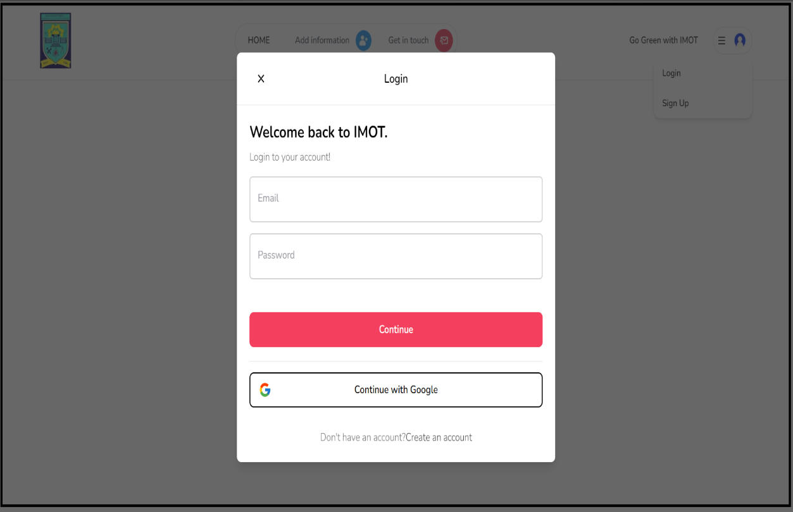Figure 3.7 Admin Login Page

**3.8. Admin Panel**

And then, admin can see the personal data of Teachers as shown in Figure 3.8 by clicking “Information Lists” button in “Profile Menu”.

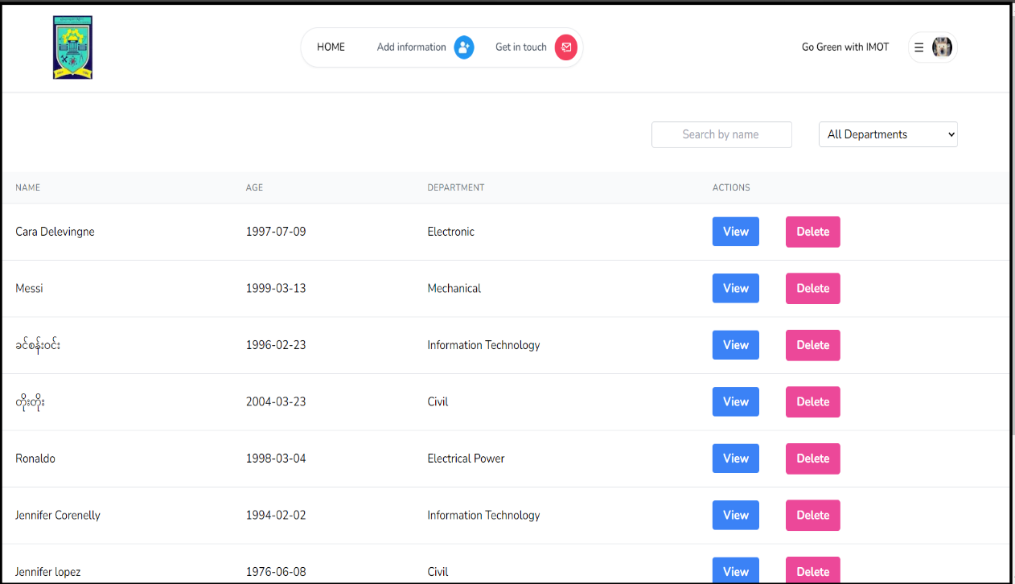Figure 3.8 Admin Panel

**3.9. Filtering Data**

Admin can filter data by selecting the drop box upon the data table as shown in Figure 3.9.

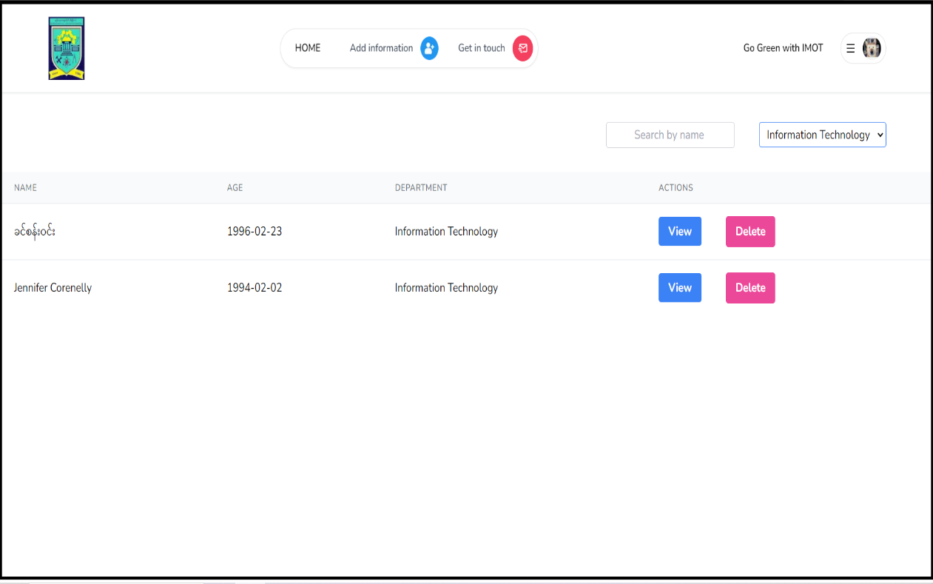Figure 3.9 Filtering Data

**3.10. Delete Data**

Admin can delete data by clicking the delete button related to that data as shown in Figure 3.10.

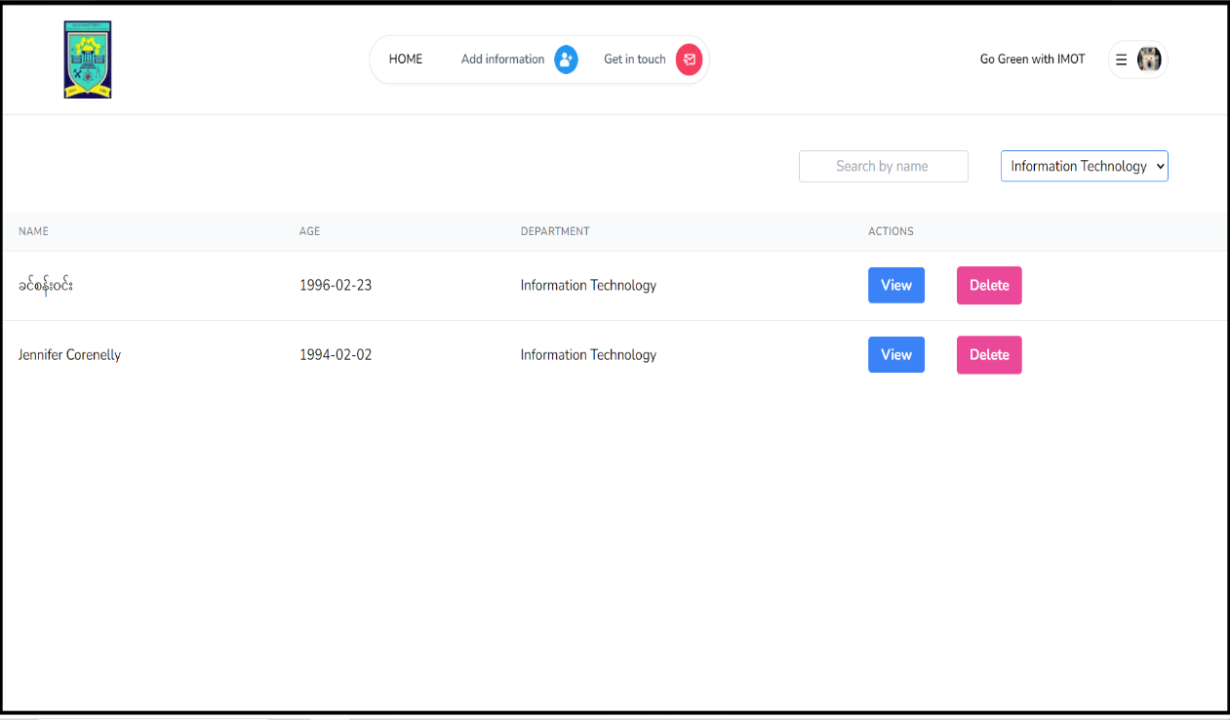Figure 3.10 Delete Data

**3.11. Search Data**

Admin can search data with the name, it can search even select on filter data as shown in Figure 3.11.

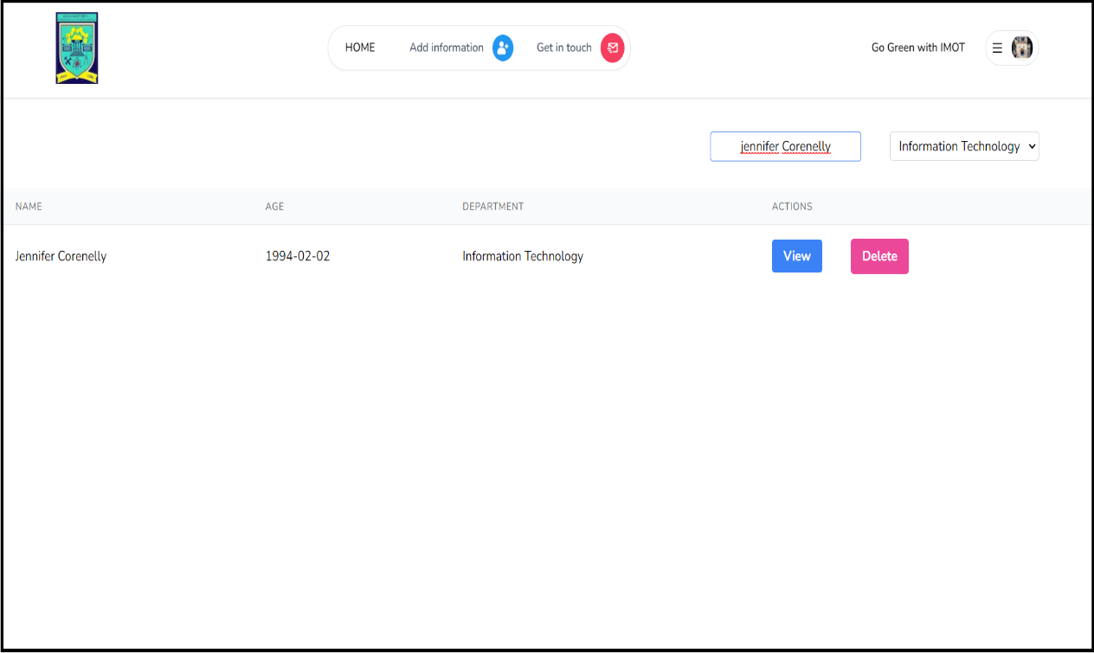Figure 3.11 Search Data

**3.12. Detail Page**

The Detail Page shows the Information shown in Figure 3.12 and 3.13.

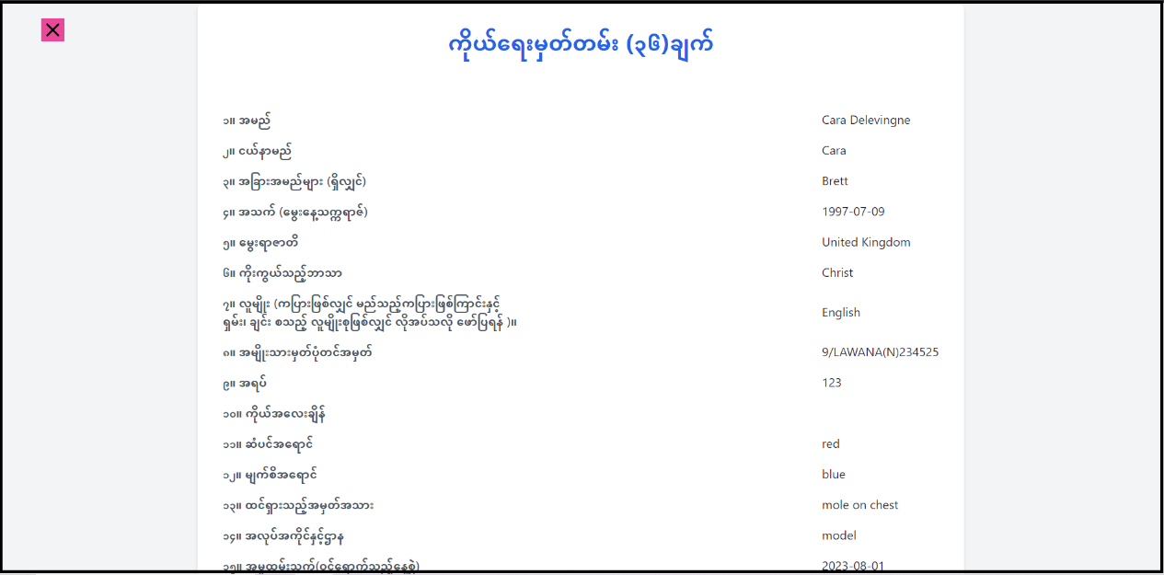Figure 3.12 Detail Page

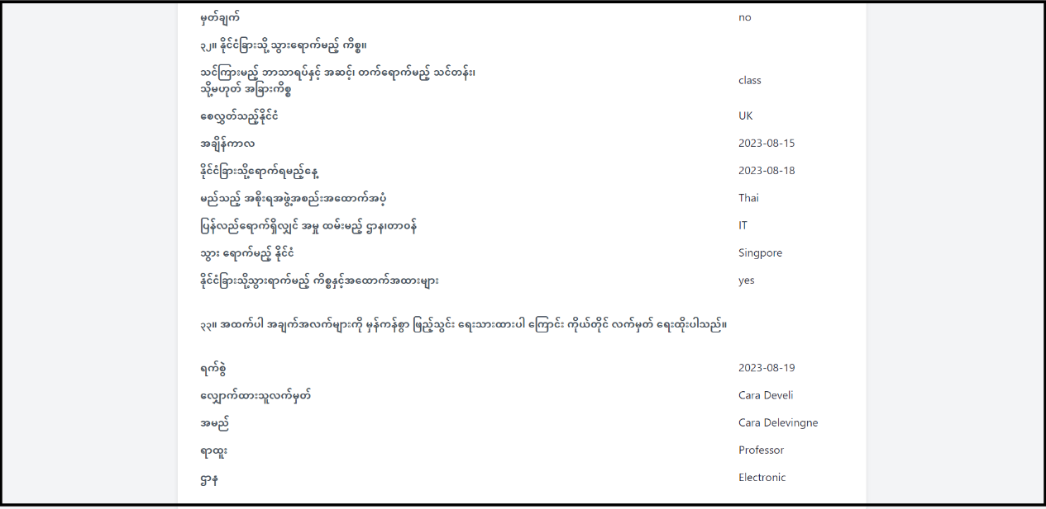Figure 3.13 Detail Page